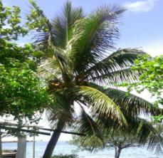 Coconut Palm (Cocos nucifera)
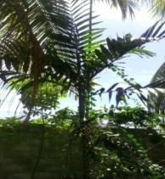 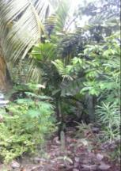 Ponapea sp
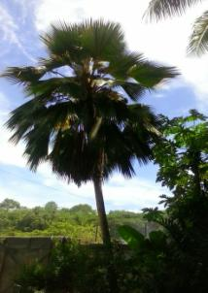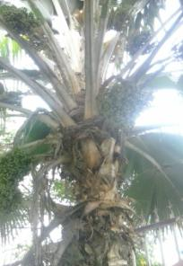
Pritchandia pacifica (Pacific fan palm)

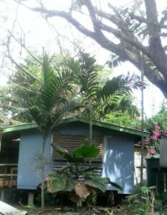P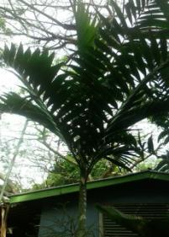
Ponapea sp. a Licuala grandis can be seen at centre of left mage
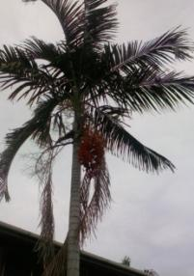 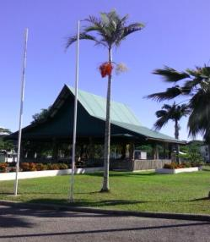Archontophoenx sp
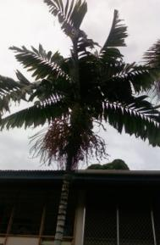 Ponapea sp
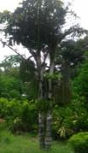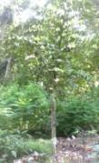 Caryota rumphiana
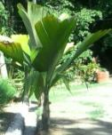 Pelagodoxa henryana
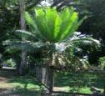 Cycus rumphii
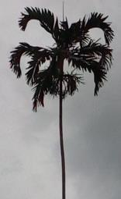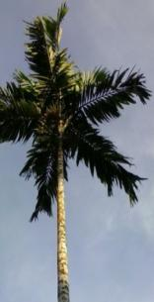 Drymorphloeus subdistichus
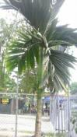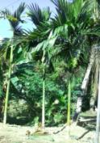 Areca catechu(Betel nut palm)
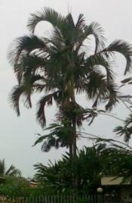 Actinorhytis calapparia (Calappa palm)
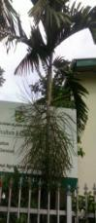 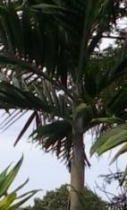 Ponapea sp
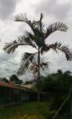 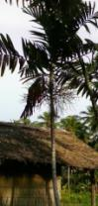Ptychosperma salomonense (medum sized stem)
__________________________________________________________________________________
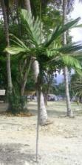 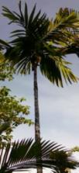Areca macrocalyx (Wild Betel Nut)
_________________________________________________________________________________
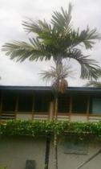 Ponapea sp
_____________________________________________________________________________________
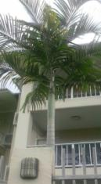Archontophoenlx sp.
__________________________________________________________________________________
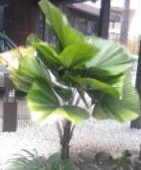 Licuala grandis 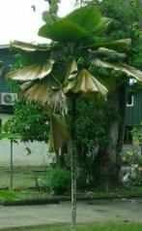
_________________________________________________________________________________
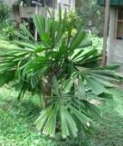 Licuala lauterbachii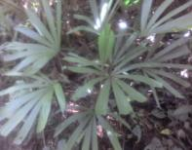
_____________________________________________________________________________________
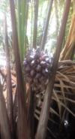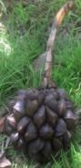 Nypa frutIcans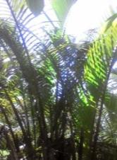
_________________________________________________________________________________
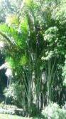 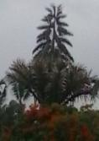 Metroxylon salomonense 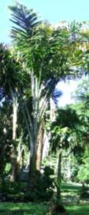
__________________________________________________________________________________
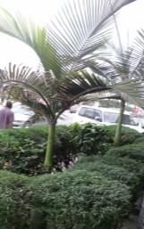 Ponapea merilli 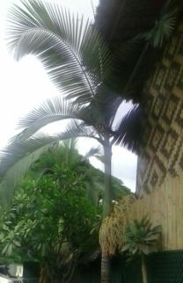
__________________________________________________________________________________
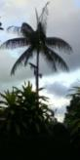 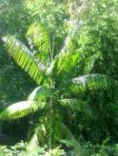 Rhopaloblaste elegans
_________________________________________________________________________________
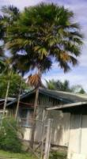 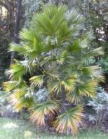Livistona woodfordii
_________________________________________________________________________________
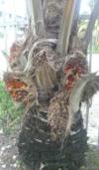 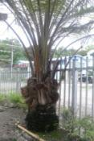Elaeis guneenensis 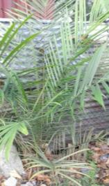
_____________________________________________________________________________________

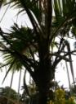 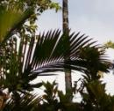 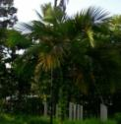 Heterospathe woodfordiana
___________________________________________________________________________________

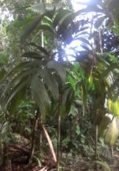 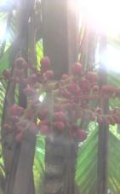 Areca guppyanna
__________________________________________________________________________________
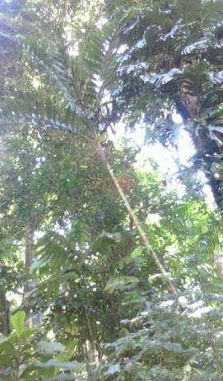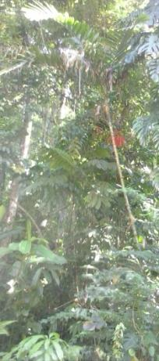
Balaka sp. (Spear palm)
_____________________________________________________________________________________
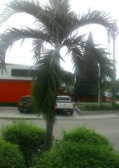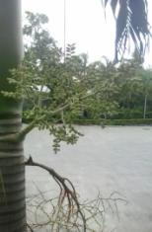 Adonida merrilli (Christmas palm)
_____________________________________________________________________________________
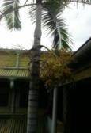 Archontophoenx sp
___________________________________________________________________________________
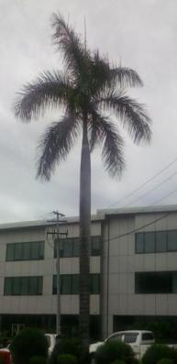 Roystonea regia (Cuban Royal Palm)
_____________________________________________________________________________________
Patrck Nanau
No. 3 Tanagai
Tandai HWY
Honiara, Solomon Islands
P.O.Box 1668, Honiara
Solomon sands
Email. pnanau@gmail.com
Mob: 677-7574537

